<html>
<head>
<title>Js function</title>
<script>
function vaidate()
{
var username=document.getElementById("username");

var age=document.getElementById("age");

var email=document.getElementById("email");
var password=document.getElementById("password");
var cpassword=document.getElementById("cpassword");
if(username.value=="")
{
alert("Must have a uername");
document.form1.username.focus();
return false;
}

if(username.value<5)
{
alert("Name must contain @ least 5 characters!");
return false;
}
if(age=="")
{
alert("Plse enter ur age");
return false;
}
if(isNaN(age))
{
alert("Plse enter a number as the age");
return;
}
N_age=Number(age)
if(N_age<20||N>age>22)
{
alert("The age must be b/w 20 & 22")
return;
}

if(email.value=="")
{
alert("Must have a Email id");
document.form1.email.focus();
return false;
}
if(password.value=="")
{
alert("Must have a password");
document.form1.password.focus();
return false;
}
if(cpassword.value=="")
{
alert("Plse confirm ur password");
document.form1.cpassword.focus();
return false;
}
if(cpassword.value!=password.value)
{
alert("Password is not matching");
return false;
}
return true;
}

</script>
</head>
<body>
<form action="" name="form1" method="post" onsubmit="validation">
Username:<input type="text" name="username" id="username"><br><br>
Age:<input type="text" name="age" id="age"><br><br>
Email:<input type="text" name="email" id="email"><br><br>
Password:<input type="password" name="password" id="password"><br><br>
Confirm Password:<input type="password" name="cpassword" id="cpassword"><br><br>
<input type="submit" value="Register">
</form>
</body>
</html>

Output

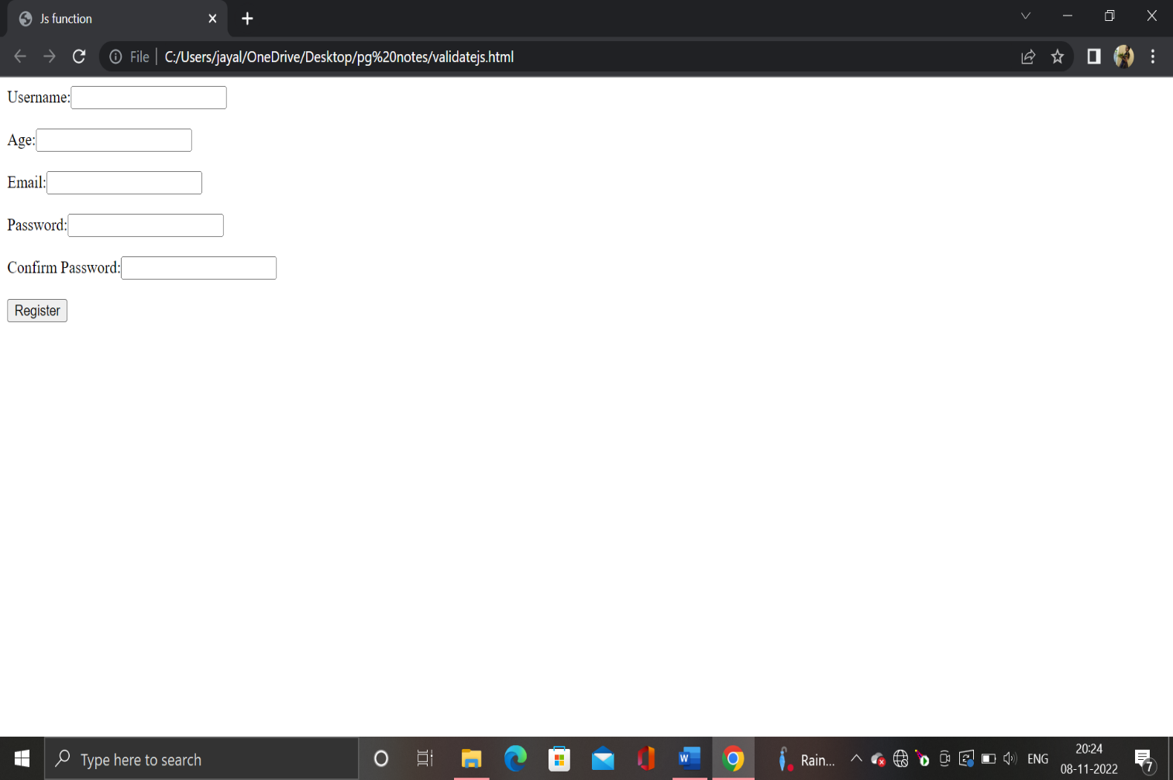

Email Validation

<html>
<head>
<script>
function Validate()
{
var email=document.getElementById(“email”).value;
var reg=/^([a-zA-Z0-9\._]+)@([a-zA-Z0-9])+.([a-z]+)(.[a-z]+)?$/;

var result=reg.test(email);
if(result==false)
{
alert(“Ur email is invalid. Plse check !”);
return false;
}
return true;
}
</script>
<body>
<form action=”” method=”post” onsubmit=”Validate()”>
<input type=”text” placeholder=”Enter ur email”>
<input type=”submit”>
</form>
</body>
</html>

BijaliJayan123._@gmail.com.in

